Recommendation System

Final Year Project – Mid Report

Session Sp18-FA21

A 4th Year Student

A project submitted in partial fulfilment of the

COMSATS University Degree

of

BSc. (Hons.)BS in Computer Science / Software Engineering (CUI)



Department of Computer Science

COMSATS University Islamabad, Lahore Campus

07 June 2021

# Project Detail

|  |  |  |  |  |  |
| --- | --- | --- | --- | --- | --- |
| Type (Nature of project) | | | [✓] **D**evelopment [ ] **R**esearch [ ] **R**&**D** | | |
| Area of specialization | | | Mobile App Development, Web App Development, Machine Learning, Natural Language Processing, Reinforcement Learning | | |
| **Project Group Members** | | | | | |
| Sr.# | Reg. # | Student Name | | Email ID | *Signature |
| (i) | SP18-BCS-159 | Ibad Ahmad | | ibad23ahmad@gmail.com |  |
| (ii) | SP18-BCS-047 | Haseeb Yaseen | | haseeb.yaseen08@gmail.com |  |
| (iii) | SP18-BCS-007 | Wahaj Hafeez | | wahajhafeez63@gmail.com |  |

*The candidates confirm that the work submitted is their own and appropriate credit has been given where reference has been made to work of others

# Plagiarism Free Certificate

This is to certify that, I am Ibad Ahmad S/D/o Naseem Anwar, group leader of FYP under registration no CIIT/SP18-BCS-159/LHR at Computer Science Department, COMSATS University Islamabad, Lahore Campus. I declare that my FYP proposal is checked by my supervisor and the similarity index is 9% that is less than 20%, an acceptable limit by HEC. Report is attached herewith as Appendix A.

Date: 06-7-2021 Name of Group Leader: Ibad Ahmad Signature: 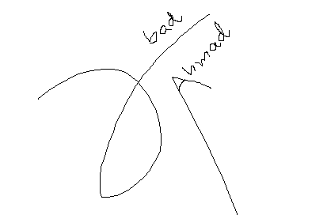

Name of Supervisor: Kanza Hamid Co-Supervisor (if any):____________________

Designation: Lecturer Designation: _____________________

Signature: _____________________ Signature: _____________________

**Abstract**

Our project is a generic recommendation system, which will be varying and adopting in the environment with the passage of time. In this project, our aim is to provide an online recommendation system service, which people can use to make their experience a lot better on contrary to their experience with some other service like Google. To find a correct, low budget orientated and location friendly service is very important and required for users but it’s not a cake walk today as there are plenty of sources which are not among those which can be reliable.

As of now, lot of recommendation systems are not able to suggest users an appropriate place that map their needs. Information mismatch have a great negative impact on such recommendation system predictions. To make a customised recommended application for imparting beneficial and powerful on line services, we want mass reviews and updated data from online databases.

**Acknowledgement**

We have worked hard on this project and we are very grateful and appreciative for the guidance from COMSATS University Lahore and the continued supervision of Ma`am Kanza Hamid. We thank Ma`am Kanza for choosing us for this project. He provided us with ongoing help, support, and guidance. Without your valuable support and assistance, it would have been impossible to start this project.

Table of Contents

1 Introduction 11

1.1 Introduction 11

1.2 Objectives 11

1.3 Problem statement 12

1.4 Assumptions & constraints 13

1.4.1 Assumptions 13

1.4.2 Constraints 13

1.5 Project motivation and scope 13

2 Requirements Analysis 16

2.1 Literature review / Existing system study 16

2.1.1 Research-Based Related Work 16

2.1.2 Application-Based Related Work 19

2.2 Stakeholders list (Actors) 21

2.3 Requirements elicitation 22

2.3.1 Functional requirements 22

2.3.2 Non-functional requirements 25

2.3.3 Requirements traceability matric 28

2.4 Use case descriptions 29

2.4.1 Use case-02: Sign Up 29

2.4.2 Use case-02: Sign Up 30

2.4.3 Use case-03: Logout 30

2.4.4 Use case-05: User Portal 31

2.4.5 Use case-06: Admin Portal 32

2.4.6 Use case-07: Recommendations 32

2.4.7 Use case-04: Model Re-Training 33

2.5 Use case design 34

2.5.1 Use case-01: User and Admin Login 34

2.5.2 Use case-02: User Sign Up 35

2.5.3 Use case-03: User and Admin Logout 35

2.5.4 Use case-04: User Portal 36

2.5.5 Use case-05: Admin Portal 37

2.5.6 Use case-06: System Recommendations 38

2.5.7 Use case-07: Model Retraining 39

2.5.8 Use case: Recommendation System (Complete System) 40

2.6 Software development life cycle model 41

2.6.1 Model Used in our project: 41

2.6.2 Why? 41

3 System Design 44

3.1 Work breakdown structure (WBS) 44

3.2 Activity diagram 45

3.2.1 Login 45

3.2.2 Register User 46

3.2.3 System Recommendations 47

3.2.4 Model Re-Training 48

3.3 Sequence diagram 49

3.3.1 Login Sequence 49

3.3.2 System Recommendations 50

3.3.3 Model Re-training 51

3.4 Software architecture 52

3.5 Class diagram 53

3.6 Database diagram 54

3.7 Network diagram (Gantt chart) 55

3.8 Collaboration diagram 56

4 System Testing 58

4.1 Unit Testing 58

4.1.1 Test Case 01: Login 58

4.1.2 Test Case 02: Recommendation 59

4.1.3 Test Case 03: Feedback 60

4.1.4 Test Case 04: View Place Profile 61

4.1.5 Test Case 05: Model Retraining 62

4.2 Integration Testing 63

4.3 Acceptance Testing 63

5 Conclusion 65

5.1 Problems faced and lessons learned 65

5.1.1 Dataset Availability: 65

5.1.2 Google Colab Limitations: 65

5.1.3 Sentiment Analysis State of the Art Models: 65

5.1.4 Team-Work and Task Management 65

5.1.5 Finding Alternatives 65

5.2 Project summary 66

5.3 Future work 66

6 References 68

**List of Tables**

Table 1: List of stakeholders (Actors) 21

Table 2: Functional Requirement-01: Sign Up 22

Table 3: Functional Requirement-02: Login 23

Table 4: Functional Requirement-03: Forget Password 23

Table 5: Functional Requirement-04: Logout 24

Table 6: Functional Requirement-05: User Profile 24

Table 7: Functional Requirement-06: Searching 24

Table 8: Functional Requirement-07: View Place Profile 25

Table 9: Non-Functional Requirement-01: Compatibility 26

Table 10: Non-Functional Requirement-02: Performance 26

Table 11: Non-Functional Requirement-03: Compatibility 26

Table 12: Non-Functional Requirement-04: Reliability 27

Table 13: Non-Functional Requirement-05: User-Friendly 27

Table 14: Non-Functional Requirement-06: Maintainability 28

Table 15: Requirement Traceability Matric 28

Table 16: Use case description-01: Login 29

Table 17: Use case description-02: Sign Up 30

Table 18: Use case description-03: Logout 30

Table 19: Use case description-05: User Portal 31

Table 20: Use case description-6: Admin Portal 32

Table 21: Use case description-7: Recommendations 32

Table 22: Use case description-04: Re-Training the model 33

Table 23: Test case-01 58

Table 24: Test case-02 59

Table 25: Test case-03 60

Table 26: Test case-04 61

Table 27: Test case-05 62

**List of Figures**

Figure 1: Phases of Recommendation System 16

Figure 2: Filtering approaches in Recommendation System 17

Figure 3: Information in reviews 18

Figure 4: Multi-Criteria Review based RS 18

Figure 5: Architecture of the proposed solution 19

Figure 6: Use case-01: Login 34

Figure 7: Use case-02: Sign Up 35

Figure 8: Use case-03: Logout 35

Figure 9: Use case-04: User Dashboard 36

Figure 10: Use case-05: Admin Portal 37

Figure 11: Use case-06: Recommendations 38

Figure 12: Use case-07: Model Retraining 39

Figure 13: Use case: Recommendation System 40

Figure 14: Incremental Model for software development life cycle 42

Figure 15: WBS 44

Figure 16: Activity Diagram 1: Login 45

Figure 17: Activity Diagram 2: Register user 46

Figure 18: Activity Diagram 3: Recommendation 47

Figure 19: Activity Diagram 4: Model Retraining 48

Figure 20: Sequence Diagram: Login 49

Figure 21: Sequence Diagram: System Recommendations 50

Figure 22: Sequence Diagram: Model Re-Training 51

Figure 23: Software Architecture 52

Figure 24: Class Diagram 53

Figure 25: Database Diagram 54

Figure 26: Network Diagram 55

Figure 27: Collaboration Diagram 56

**Chapter 1**

**Introduction**

# Introduction

## Introduction

In different fields, including e-commerce, social media applications, and video platforms, recommendation systems [1] are one of the most important aspects. They help people to suggest what might be interesting, useful, and relatable for them.

Models are built to recommend the content which is appropriate according to user requirement or pattern by depending on different factors like user information, interest of user, targeted age, reviews and ratings. This helps to keep user engage with the application and it becomes easy to suggest something to users according to his/her needs by using provided data.

Starting with the basic idea, Recommendation system is sort of data filtering method, in which on the basis of certain parameters you show certain data to user from database. The parameters can be rating, prices/rates, accessing comfort, nearby one etc. In simple words, Recommendation systems provides only that information which will be user hoping against the content he has provided to system.

Now our goal is to create a recommendation system which will suggest its users about multiple things like hospitals, restaurants, hotels etc. depending on the different parameters like ratings, remarks/feedback and the list goes on. On the other hand, system must be able to be adaptive with new parameter’s value which can help the system to remain up to date with the future recommendations.

Now if we talk about the basic parameters, these are as following

* Rating
* Reviews
* Distance
* Price

## Objectives

* To make it easy and effective for users to get best recommendations nearest to their location and easily accessible.
* To develop such application that will automate the function of finding the appropriate recommendation according to user requirement, thus bring easiness, save time and efforts needed to find a best suitable suggestion.
* To overcome the drawbacks of traditional approaches for finding a thing by developing such recommendation system that will uses natural language processing and machine earning techniques to produce a recommendation list.
* To develop such intelligent recommendation system that performs accurately and efficiently and help users to know about the authentic, best, affordable, nearest doctor, restaurants, hotels etc. whom which they can trust or prefer.
* To create a model, that will vary time to time in order to acquire excellence in further recommendations.

## Problem statement

In the modern world, a number of applications are there that suggest what is most appropriate for the user. Recommendation systems are widely used to suggest the appropriate, relevant, according to mood and requirement. Tech giants like Facebook, YouTube, and Netflix uses RS to show what is according to the pattern of users. On the other hand, applications like Yelp, Food Panda, etc. use the RS to show the results which are according to the reviews and ratings of other users that have previously experienced that place. Each of these platforms uses a different type of RS for generating different types of recommendations. But most of the applications are handling a single domain, like food, cars, entertainment, etc.

Our project is to come up with a generic recommendation system that would be able to recommend any field of the second type explained i.e. Recommendation on the basis of feedback. The generic model would analyse textual data (reviews) and after that, we will generate the final rating on the basis of the combination of user ratings and reviews generated by the model on the basis of reviews. Moreover, we will add Reinforcement Learning so that this process becomes dynamic i.e. as more reviews come, ratings will be changed according to reviews.

## Assumptions & constraints

### 1.4.1 Assumptions

The project is supposed to be a user-friendly web and mobile application, which would be able to provide the recommendation of places in your surroundings on the basis of the feedback provided by the other users. The services users will get are:

* Users will get recommendations on the basis of the experience of other users.
* Recommendations given to users will be dynamic, which will be changed over the period of time.
* Users will be able to see the place's profile and read comments to get a better idea about any place.
* Users will be able to share his/her experience in terms of feedback.

### 1.4.2 Constraints

There are many positive aspects of the project in different ways, but there is some limitation of the project too, both technical and non-technical. As for the technical side, our recommendation system depends on the reviews and we don't have any control over the language used in reviews, which may lead to the problem of discarding of reviews. Another problem is that no system has a perfect database that covers all areas, so if someone wants to get a response about a location that does not exist in our database, in that case we would depend upon Google MAP API, and the reason behind this is that it might take long enough time to respond if we fetch data, feed to model and then show ratings. As far as non-technical constraints are concerned, in the initial stage, we will only show recommendations and there will be no such system like appointment or booking of places. Our System won’t be able to provide product reviews from several businesses like shopping malls etc.

## Project motivation and scope

Since we are living in the 3rd word country and are among a developing one in Asia we don’t have recourses that can cover up the mass requirements. There are hundreds of thousands of cases weekly that are unable to get even first aid timely especially those who are lying in or near to rural areas. Pakistan’s population which belongs to this section is reported to be 63.09% in 2019 which is a shocking stat itself. [2]

One of the many examples we can site here is of Muniba Mazari [3]also known as the Iron Lady of Pakistan. She is a Pakistani activist, anchor artist, model, singer and motivational speaker. On 27 February 2008, Muniba and her husband were travelling from [Quetta](https://en.wikipedia.org/wiki/Quetta) to [Rahim Yar Khan](https://en.wikipedia.org/wiki/Rahim_Yar_Khan_District). Their car met with an accident, in which she sustained several major injuries, including broken bones in her arm, rib-cage, shoulder blade, collarbone and spine. Her [lungs](https://en.wikipedia.org/wiki/Lungs) and [liver](https://en.wikipedia.org/wiki/Liver) were also deeply cut. Moreover, her entire lower body was left paralyzed. She was taken to a nearby hospital, which was ill-equipped to deal with such a severe case. She was then taken to her native hospital but result didn’t change as there were no doctors or equipment’s to handle the patient either. She was then moved to a hospital in [Rahim Yar Khan](https://en.wikipedia.org/wiki/Rahim_Yar_Khan_District), and eventually, she was admitted to the [Agha Khan Hospital](https://en.wikipedia.org/wiki/Aga_Khan_University_Hospital,_Karachi), [Karachi](https://en.wikipedia.org/wiki/Karachi). Post-surgery, she was left bed-ridden for two years.

The idea to cite the above example is there are several cases of these context where the population is unable to find the emergency service just because of the unawareness and no helping hands that can lead them to desired output. Our aim is same, to provide that sort of application which will be able to guide with best possible source of help that user can imagine or desire at runtime.

Natural Language processing is a vast field that acts as an umbrella for many different fields. Getting Recommendations by using reviews are also one of the things which come under this. This application will cover most of the modules that we counter in normal life ranging from Hotels, Malls, Doctors etc. Furthermore, user can apply filters as per their use. In future, more modules can be added to this system as user requirements increase and so do filters We are going to develop such a system which will help in the following:

* Generate recommendations on the basis of feedback i.e. ratings and reviews.
* Make a dynamic system by introducing Reinforcement learning, so that ratings will be changed over the period of time according to new feedbacks

.

**Chapter 2**

**Requirement Analysis**

# Requirements Analysis

## Literature review / Existing system study

There is a lot of work in the field of Recommendation systems has been done. Recommendations systems are used to recommend different things while considering multiple parameters. From the literature and existing systems, some related applications, working platforms and researches have been discussed below, apart from working principles of RS.

### Research-Based Related Work

1. **Recommendation systems: Principles, methods and evaluation**

This is a research-based article [4], which explains the characteristics, methods, and potential of different types of recommendation systems that are used to show the data which is according to the interest of the user.

The authors explained multiple types and phases of RS and explained the working of each phase. One of the most important phases is the collection of information for different types of recommendations. Types are explained in detail, which are:

* Explicit Feedback
* Implicit feedback
* Hybrid feedback

Phases of systems are divided as follow which shows the relationship between each phase:

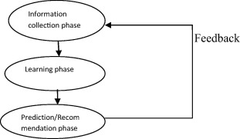

Figure 1: Phases of Recommendation System

Once the phases of recommendations are described, filtering techniques were discussed that was used to give recommendations. The authors have described each filtering method, its pros & cons, sub-types, and examples of each filtering approach in the paper. Figure 2 is showing the filtering approaches for RS.

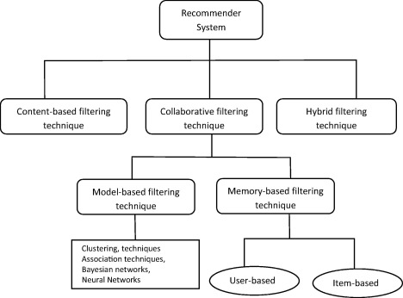

Figure 2: Filtering approaches in Recommendation System

1. **Multi-Criteria Review-Based Recommender System–The State of the Art**

In this research paper [5], there are multiple parameters that have been discussed, on the basis of which RS can generate ratings or in other words can show better results. The authors explained the importance of reviews and the advantages of taking "reviews" into consideration. Moreover, problems have been discussed which are there, when we work with "reviews". Figure 3 shows the information which we can extract from reviews.

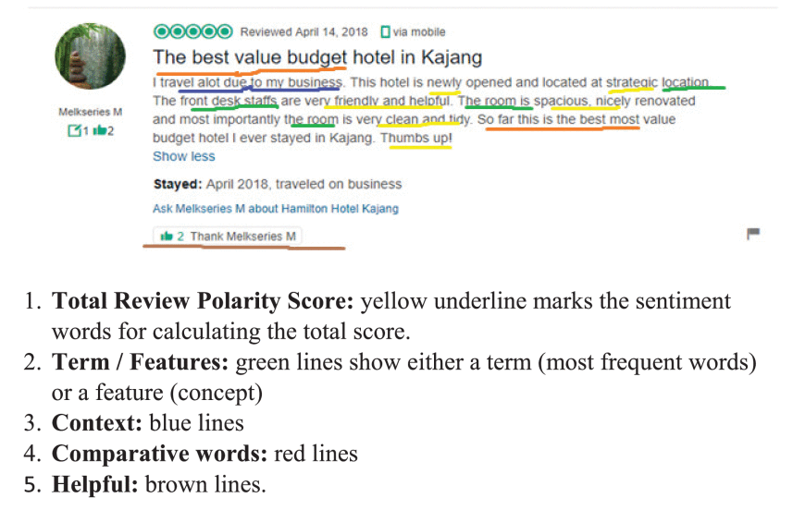

Figure 3: Information in reviews

Another section of this research paper is Multi-Criteria RS which explains that how we can generate better recommendations by considering multiple factors. This is what we are trying to implement in our FYP i.e. consider ratings and reviews of the place and generate ratings based on both. Figure 4 depicts different steps of Multi-Criteria Review based RS.

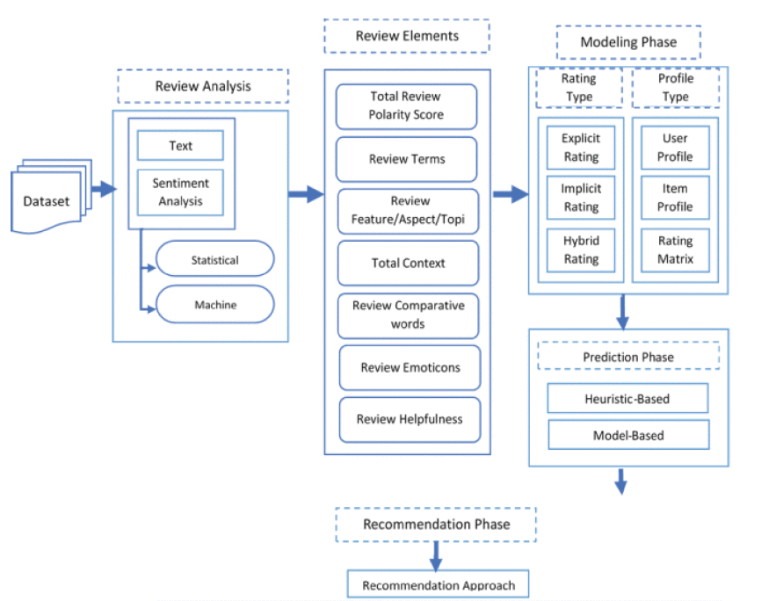

Figure 4: Multi-Criteria Review based RS

1. **Recommender System Based on Consumer Product Reviews**

This research paper [6] proposed one of the solutions to create a recommendation system based on reviews. This solution considers mining different parameters from the text, and on the basis of that, we evaluate multiple factors. Moreover, prioritization and ontology have also been created to recommend the best on the basis of reviews. In the paper, RS for cameras is developed. The following Figure 5 shows the general flow of the proposed solution.

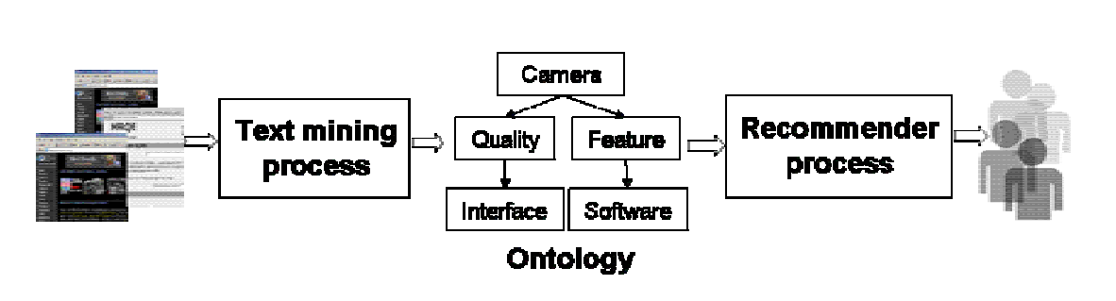

Figure 5: Architecture of the proposed solution

### Application-Based Related Work

1. **Yelp**

Yelp [7]is one of the biggest platforms in the RS category. Yelp recommends multiple places related to different fields base on the reviews and ratings of previous users. For instance, if you select the restaurants and search for "steaks", depending on which city you are in, it will show you the highest-rated restaurants that serve steak. You can further filter the recommendations on the basis of different factors like nearby, price-efficient, etc. But Yelp's services are not available in our Region.

1. **TripAdvisor**

TripAdvisor [8] is another app that recommends restaurants, hotels, vacation rentals in multiple countries and this depends on the ratings and reviews given by previous users. One can see the profile of the place which includes photos, reviews, and ratings about the place. You can also get customized recommendations depending on the price range and nearby to someplace. But recommendations are always from best high to low ratings which are calculated by considering the feedback of users.

1. **Urban Spoon**

Urban Spoon [9] is another RS-based app that is like Yelp but only handles a single module i.e. finding places to eat. By using Urban Spoon, you can not only search places to eat but customize searches like the internet availability, category of food, etc. On Urban Spoon not only business owners and users provide reviews but also local food critics and chefs also give their reviews.

**4) Pinterest**

Pinterest has one of the most widely used recommender networks (Pixie), with over 10 billion suggestions served per day. They’ve installed personalization engines that can serve the good recommendation to the right customer at the right time, selecting from a pool of over 100 billion artefacts in real time—by combining the data they've accumulated over the time with human curation. [10]

**5) Netflix**

When you use Netflix, their recommendations system tries to make it as easy as possible for you to find a show or movie to watch. They calculate the probability of users for watching a specific movie in Netflix based library on a variety of factors, including:

* your experiences using their service (such as your viewing history and how your ratings),
* other participants with common preferences and values

These bits of information are used as inputs to Netflix algorithms [11].

## Stakeholders list (Actors)

In table 1 below, List of all the stakeholders are mentioned.

Table 1: List of stakeholders (Actors)

| **Stakeholder** | **Area/Skill set** | **Type of Stakeholder** | **Expectations** | **Influence** | **Impact** |
| --- | --- | --- | --- | --- | --- |
| Software Engineer | Software | Internal | applies software engineering principles to the development, maintenance, testing, and evaluation of applications | High | High |
| Database Developer | Database | Internal | Database components of the application must be created or maintained. | Low | Low |
| Developer | Development | Internal | builds and creates applications, writes, debugs, and executes application source code | High | High |
| Natural Language Processing NLP) Engineer | Programming, Statistical Analysis, Text Representation | Internal | Transforms natural language data representation into features that classification algorithms may understand. | Low | High |
| Machine Learning Engineer | Programming, Statistics, Data Modeling and Evaluation | Internal | creates algorithms and builds model that enables application to take action automatically | High | High |
| Application Tester | Analytical, Critical, Logical | Internal | Creates algorithms and models that allow an application to take action on its own. | Low | High |
| SQA Engineer | Quality Assurance | Internal | In order to ensure consistency, track, evaluate, and test the application during production. | High | Low |
| End User | Customer | External | After the software has been completely produced, use it and provide input. | Low | High |
| Project Team | Database, Machine Learning, Development | Internal | Manage Databases , models retraining and development stuff | High | High |
| Project Supervisor | Machine Learning | Internal | Supervision of the project | High | High |

## Requirements elicitation

### Functional requirements

In Software Engineering, functional requirements define the scope and working of system components in a way that is feasible for both client and the team developing it. It differs software to software.

#### FR – 01 User Sign Up:

In Table 2 below, the functional requirements of the sign up page are mentioned.

Table 2: Functional Requirement-01: Sign Up

|  |  |
| --- | --- |
| FR 01 – 01 | User enters his/her Full name |
| FR 01 – 02 | User enters his/her username |
| FR 01 – 03 | User enters password (must contain alpha-numeric and special characters and should be at least six characters long) |
| FR 01 – 04 | User confirms his/her password |
| FR 01 – 05 | User accepts Terms and conditions checkbox |
| FR 01 – 06 | User clicks on the signup button |
| FR 01 – 07 | Error is displayed in-case of any failed step |
| FR 01 – 08 | User can also signup with their Google account |

#### FR – 02 User Log in:

In Table 3 below, the functional requirements of the login page are mentioned.

Table 3: Functional Requirement-02: Login

|  |  |
| --- | --- |
| FR 02 – 01 | User enters his/her Full name |
| FR 02 – 02 | User confirms his/her password |
| FR 02 – 03 | User accepts Terms and conditions checkbox |
| FR 02 – 04 | User clicks on the log in button |
| FR 02 – 05 | Error is displayed in-case of any failed step |
| FR 02 – 06 | User can also sign in with their Google account |

#### FR – 03 Forget Password:

In Table 4 below, the functional requirements of the forget password page are mentioned.

Table 4: Functional Requirement-03: Forget Password

|  |  |
| --- | --- |
| FR 03 – 01 | User enters his/her Email |
| FR 03 – 02 | User gives the verification code he’d received through email |
| FR 03 – 03 | User enters new password |
| FR 03 – 04 | User confirms the new password |
| FR 03 – 05 | User clicks the reset password button |
| FR 03 – 06 | Error is displayed in-case of any failed step |

#### FR – 04 User Log Out:

In Table 5 below, the functional requirements of the login page are mentioned.

Table 5: Functional Requirement-04: Logout

|  |  |
| --- | --- |
| FR 04 – 01 | User clicks on sign out button |
| FR 04 – 02 | He/ She is redirected to login page |

#### FR – 05 User Profile:

In Table 6 below, the functional requirements of the user profile/dashboard are mentioned.

Table 6: Functional Requirement-05: User Profile

|  |  |
| --- | --- |
| FR 05 – 01 | User goes to profile page |
| FR 05 – 02 | He/ She can update his personal information |
| FR 05 – 03 | User can delete his/her profile permanently (warning will be generated and extra verification step will be given) |
| FR 05 – 04 | In-case of account deletion , all of his data from database will be deleted and will be redirected to log in page afterword’s. |

#### FR – 06 Searching / Get Recommendations:

In Table 7 below, the functional requirements to get recommendations are mentioned.

Table 7: Functional Requirement-06: Searching

|  |  |
| --- | --- |
| FR 06 – 01 | User gives the requirements. |
| FR 06 – 02 | User applies the filter |
| FR 06 – 03 | User clicks the search button |

#### FR – 07 View Places Profiles:

In Table 8 below, the functional requirements to view place profile are mentioned.

Table 8: Functional Requirement-07: View Place Profile

|  |  |
| --- | --- |
| FR 07 – 01 | User enters place he/she wants to see profile of |
| FR 07 -02 | User clicks the view profile button |
| FR 07 – 03 | Place Profile will be displayed like location, rating and top comments etc. |
| FR 07 – 04 | User can gives his feedback by clicking on the give feedback button |
| FR 07 – 05 | User will give a place its rating ,comment and the required information |
| FR 07 – 06 | User feedback will be added . |
| FR 07 – 07 | Error is displayed in-case of any failed step |

### Non-functional requirements

On the other hand, non-functional requirements describe how system should behave. In short context, it represents the quality or attributes of the system. These requirements cover up all the left-overs from the functional requirements.

#### NFR – 01 Transportability / Compatibility:

In Table 9 below, the non-functional requirements related to compatibility are mentioned.

Table 9: Non-Functional Requirement-01: Compatibility

|  |  |
| --- | --- |
| NFR 01 – 01 | Systems android and web app should be compatible with all the desktops and native devices respectively. |
| NFR 01 – 02 | System shouldn’t undergo any major changes when sifting to any other Operating System |
| NFR 01 - 03 | Both apps should be consistent and generalize throughout |

#### NFR – 02 Performance:

In Table 10 below, the non-functional requirements related to performance of the application are mentioned.

Table 10: Non-Functional Requirement-02: Performance

|  |  |
| --- | --- |
| NFR 02 – 01 | Performance of the system must be good |
| NFR 02 – 02 | System’s quick response will outline its performance irresponsive of the mass interacting with him. |

#### NFR – 03 Secure:

In Table 11 below, the non-functional requirements related to secure environment of platform are mentioned.

Table 11: Non-Functional Requirement-03: Compatibility

|  |  |
| --- | --- |
| NFR 03 – 01 | The system must be secure so do the database which has primary role in system functioning properly |
| NFR 03 – 02 | System Database should be on a secure cloud platform. |
| NFR 03 - 03 | System should ensure both data integrity and user privacy |
| NFR 03 - 04 | The system should maintain correct as well as consistent information which will help to generate good recommendations. |

#### NFR – 04 Reliability:

In Table 12 below, the non-functional requirements related to reliability are mentioned.

Table 12: Non-Functional Requirement-04: Reliability

|  |  |
| --- | --- |
| NFR 04 – 01 | System should only respond to correct and valid feedbacks and ignore the fake ones. |
| NFR 04 – 02 | System can also block the fake user permanently |

#### NFR – 05 Usability / User Friendly:

In Table 13 below, the non-functional requirements related to user friendly environment of the application are mentioned.

Table 13: Non-Functional Requirement-05: User-Friendly

|  |  |
| --- | --- |
| NFR 05 – 01 | System must present a formal documentation tutorial in the form of pop-ups for newbies. |
| NFR 05 – 02 | The system should only focused on what is primary / important for the user and don’t focus on what would put the user in any type of mess or confusion |
| NFR 05 - 03 | Web Application should be information orientated while native app should be task orientated. |

#### NFR – 06 Maintainability:

In Table 14 below, the non-functional requirements related to maintenance are mentioned.

Table 14: Non-Functional Requirement-06: Maintainability

|  |  |
| --- | --- |
| NFR 06 – 01 | The system should be maintained properly. Whenever there is a problem, it must be fixed as soon as possible. |
| NFR 06 – 02 | Moreover, the system must be timely updated according to the needs of the user |

### Requirements traceability matric

In Table 15 below, Requirement traceability matrix has been displayed.

Table 15: Requirement Traceability Matric

|  |  |  |  |  |
| --- | --- | --- | --- | --- |
| **Test Case ID** | **FR_ID** | **Description of Requirement** | **Objective** | **Priority** |
| 01 | FR-01 | The system will provide users with 2 types of accounts i.e. Admin and User. | Register a new user. | High |
| 01 | FR-02 | The system will facilitate the user with a login system. | Logging user account. | High |
| 02 | FR-06 | The system will facilitate user with the recommendation of different places based upon different parameters | Make Recommendation of Places | High |
| 03 | FR-07 | The system will shows a complete Place profile to the user which he has just searched with options like place reviews, rating or location etc. | Display Place Profile to the user | High |
| 04 | FR-07 | User can add his respective review of that place | User Feedback about Place | High |

## Use case descriptions

### Use case-02: Sign Up

The use case description for the login process is shown in Table 16.

Table 16: Use case description-01: Login

|  |  |
| --- | --- |
| **ID:** | 1 |
| **Name of Use Case:** | Login |
| **Actors:** | Admin, User, Database |
| **Description:** | The admin/user can log in to the application. |
| **Pre-Condition:** | Admin/User should’ve their account registered beforehand. |
| **Post-Condition:** | Admin/User has been signed into the application, successfully. |
| **Events:** | 1. Admin/user opens the app. 2. Admin/user clicks on the login / sign in button. 3. Admin/user fills the required fields (username and password) 4. After the authentication has been done, user will be redirected to dashboard |
| **Alternatives Flow:** | In case of forget password, user will be provided with the reset link by the app. |
| **Exceptions:** | None |

### Use case-02: Sign Up

The use case description for the sign up process is shown in Table 17.

Table 17: Use case description-02: Sign Up

|  |  |
| --- | --- |
| **ID:** | 2 |
| **Name of Use Case:** | Sign Up |
| **Actors:** | User, Database |
| **Description:** | User can create their respective account for application. |
| **Pre-Condition:** | No account of that credentials already exist. |
| **Post-Condition:** | User account has been created and they are logged in |
| **Events:** | 1. User opens the app. 2. User clicks on the sign up button. 3. User fills the required fields of the form 4. After the sign up procedure has been done, user will be redirected to dashboard |
| **Alternatives Flow:** | User already has an account. |
| **Exceptions:** | None |

### Use case-03: Logout

The description of the use case of the logout process is shown in Table 18.

Table 18: Use case description-03: Logout

|  |  |
| --- | --- |
| **ID:** | 3 |
| **Name of Use Case:** | Logout |
| **Actors:** | Admin, User |
| **Description:** | The user/admin can logout from the application. |
| **Pre-Condition:** | The user/admin should be signed in his/her account. |
| **Post-Condition:** | User/admin has been successfully logged out from the application. |
| **Events:** | 1. The user presses the logout button. 2. The user logs out and the login page appears. |
| **Alternatives Flow:** | The user has already logged out. |
| **Exceptions:** | None |

### Use case-05: User Portal

The use case description for the User Portal is shown in Table 19.

Table 19: Use case description-05: User Portal

|  |  |
| --- | --- |
| **ID:** | 5 |
| **Name of Use Case:** | User Portal |
| **Actors:** | User, Database, Google Map API, Trained Model |
| **Description:** | User can manage his profile , view profiles of the places , add places to his/her favorites section, give feedback in the form of reviews and comments, get recommendations |
| **Pre-Condition:** | User has been logged in. |
| **Post-Condition:** | User has carried out its desire goal |
| **Events:** | 1. User opens the app. 2. User logs in 3. User chooses either of the task he wants to perform 4. User performs the task by following the valid set of operations |
| **Alternatives Flow:** | In case of forget password, user will be provided with the reset link by the app. |
| **Exceptions:** | User Portal has been deleted due to some reason by admin or by himself accidently. |

### Use case-06: Admin Portal

The use case description for the Admin Portal is shown in Table 20.

Table 20: Use case description-6: Admin Portal

|  |  |
| --- | --- |
| **ID:** | 6 |
| **Name of Use Case:** | Admin Portal |
| **Actors:** | Admin, Database |
| **Description:** | Admin can view the users, their details and can check recommendations and other functions of app. Moreover, can manage app users either by deleting or updating. |
| **Pre-Condition:** | Admin has logged in or admin is a valid admin |
| **Post-Condition:** | Admin has carried out its desire goal |
| **Events:** | 1. Admin opens the app. 2. Admin logs in 3. Admin chooses either of the task he wants to perform 4. Admin performs the task by following the valid set of operations |
| **Alternatives Flow:** | None |
| **Exceptions:** | Admin is not a valid admin |

### Use case-07: Recommendations

The use case description for the Admin Portal is shown in Table 21.

Table 21: Use case description-7: Recommendations

|  |  |
| --- | --- |
| **ID:** | 7 |
| **Name of Use Case:** | Recommendations |
| **Actors:** | User, Database, Trained Model, Google MAP API |
| **Description:** | Application shall get location given by user and will show recommendation according to need. |
| **Pre-Condition:** | Location must be valid. |
| **Post-Condition:** | Recommendations have been shown to user. |
| **Events:** | 1. User enters location and choose the recommendations which he/she needs. 2. From database data will be retrieved against the location. 3. Retrieved recommendations will be shown to user according to system ratings of the places available at that location. |
| **Alternatives Flow:** | Entered location’s data is not available in database. In that case following flow will be considered.   1. User enters location and choose the recommendations which he/she needs. 2. If data is not in database, it will be retrieved from Google MAP API. 3. Retrieved recommendations will be shown to user according to Google ratings of the places available at that location. 4. After that data of that location will be feed to trained model and data will be maintained of that location, according to Model’s generated ratings. |
| **Exceptions:** | None |

### Use case-04: Model Re-Training

The use case description for retraining the model is shown in Table 22.

Table 22: Use case description-04: Re-Training the model

|  |  |
| --- | --- |
| **ID:** | 4 |
| **Name of Use Case:** | Re-training the model |
| **Actors:** | Database, Trained Model |
| **Description:** | Application shall get feedbacks given by user and the model from the database and then retrain it. |
| **Pre-Condition:** | Database must exist with the trained model and feedbacks. |
| **Post-Condition:** | Model has been retrained. |
| **Events:** | 1. Feedbacks have been feed to trained model. 2. Timeout has been occurred for retraining of the model 3. Database will feed in the updated dataset with latest reviews and comments to model 4. Application has been updated accordingly after the retraining |
| **Alternatives Flow:** | Timeout has not been occurred for retraining phase |
| **Exceptions:** | None |

## Use case design

### Use case-01: User and Admin Login

The use case for the login process for the user and admin is shown in Figure 6. The users and admin will enter their credentials, the System will match them with the database and the appropriate function will run. While there remains the option of "forgot password" for users.

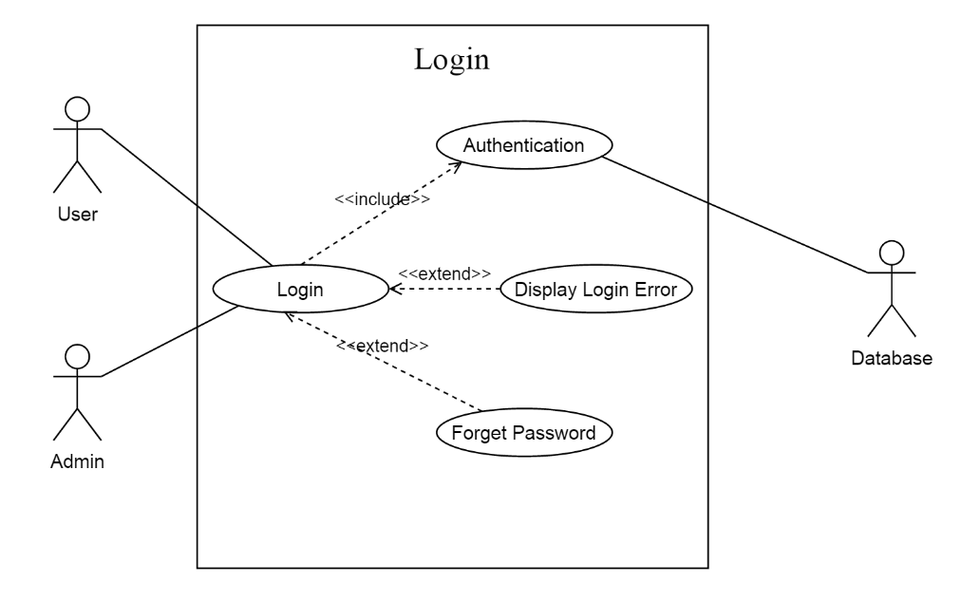

Figure 6: Use case-01: Login

### Use case-02: User Sign Up

The use case for the signup process for the user is shown in Figure 7.

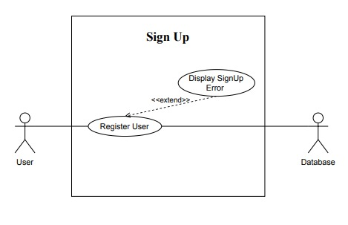

Figure 7: Use case-02: Sign Up

### Use case-03: User and Admin Logout

The use case for the logout process for the user and admin is shown in Figure 8.

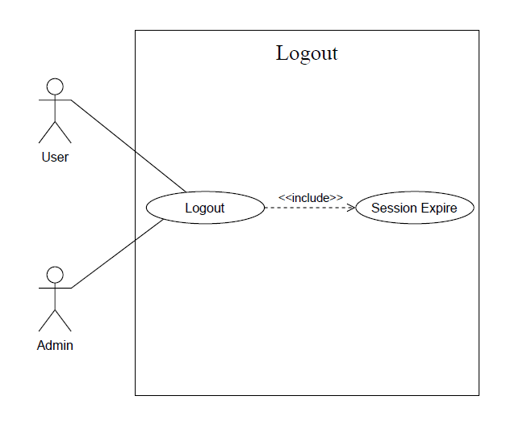

Figure 8: Use case-03: Logout

### Use case-04: User Portal

The use case for the user portal shown in Figure 9. Users can interact with applications in multiple ways. First of all, they will register themselves. To get the recommendations, the user will enter its location and the whole process of giving recommendations will be performed. Users can view places and also give feedbacks against places, while the other options are related to account management.

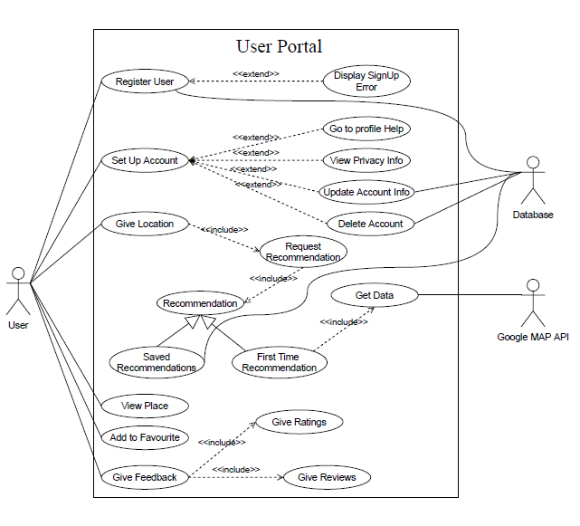

Figure 9: Use case-04: User Dashboard

### Use case-05: Admin Portal

The use case for the admin portal is shown in Figure 10. Admin has authority to view users, update the status of any user or block any user from the application.

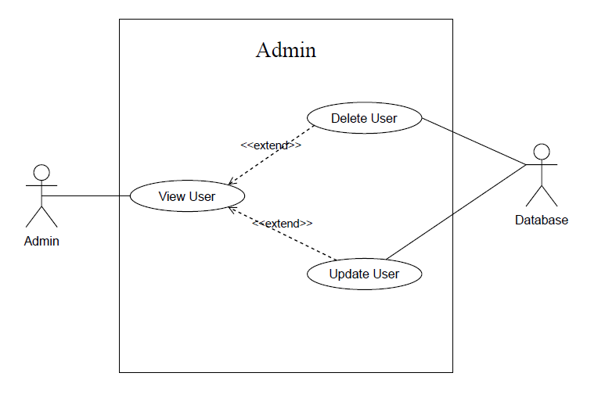

Figure 10: Use case-05: Admin Portal

### Use case-06: System Recommendations

The use case for system recommendations place is shown in Figure 11. To give recommendations to the user, the system will obtain its location. Obtained location will be checked in the database, if data of that location is available, recommendations will be given according to system ratings of the places. But if the location is not there then we will fetch data from Google MAP API and for the first time show ratings of google. Afterward, the fetched data will be feed to the trained model, and ratings of places will be stored in the database for latter recommendations.

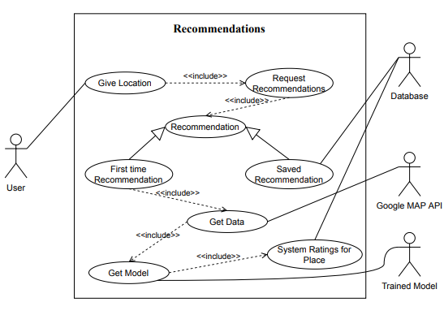

Figure 11: Use case-06: Recommendations

### Use case-07: Model Retraining

The use case for the model training is shown in Figure 12. After the defined period of time, feedbacks from the users will be feed to the trained model. Reinforcement learning will come to action; ratings will be updated according to feedbacks. This will make our system ratings dynamic.

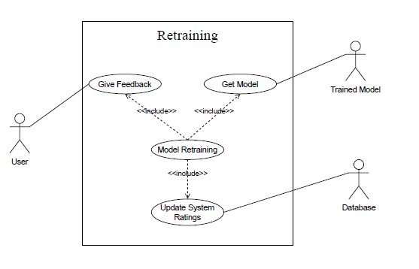

Figure 12: Use case-07: Model Retraining

### Use case: Recommendation System (Complete System)

The use case in figure 13 depicts the overview of the complete recommendation system by combining all modules of the system in one diagram for a better understanding of the viewer.

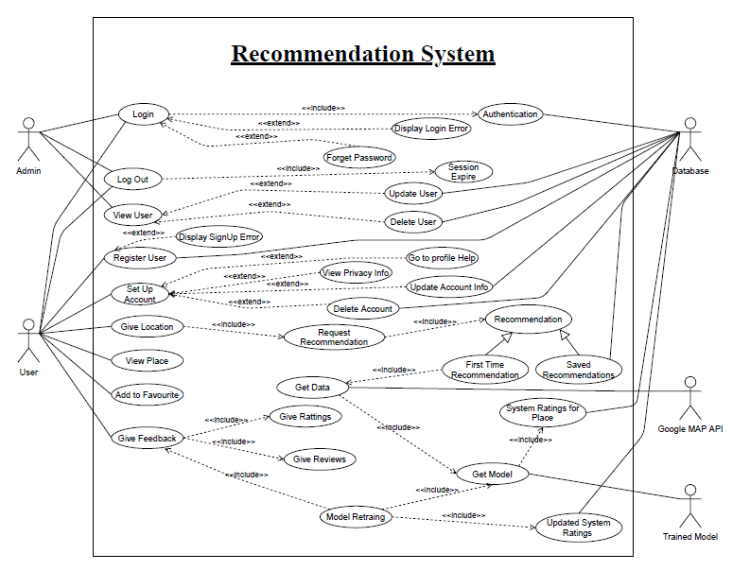

Figure 13: Use case: Recommendation System

## Software development life cycle model

One of the essential thoughts of the product advancement measure is SDLC models which represents Software Development Life Cycle models. There are numerous development life cycle models that have been created to accomplish diverse required targets. The models determine the different phases of the interaction and the request where they are done. The most utilized, mainstream and significant SDLC models are given underneath:

* Waterfall model
* V model
* Incremental model
* RAD model
* Agile model
* Iterative model
* Spiral model
* Prototype model

### Model Used in our project:

The incremental form model is a strategy for programming advancement where the model is planned, carried out and tried gradually (somewhat more is added each time) until the item is done. It includes both turn of events and support. The item is characterized as completed when it fulfils the entirety of its prerequisites. Every cycle goes through the prerequisites, plan, coding and testing stages. What's more, each ensuing arrival of the framework adds capacity to the past functionalities until all planned practically has been executed. This model joins the components of the waterfall model with the iterative way of thinking of prototyping.

### Why?

* This model will be possible for us if there is any shift needed all through the task. Thus, it would be more sensible
* It is a lot simpler to recognize the dangers and handle them independently in the emphases
* Our venture would require amendments until we get our last undertaking.
* Testing and troubleshooting during the more modest cycles would be a superior alternative. Every build is an achieved handily in milestones.

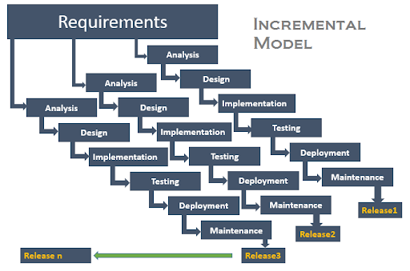

Figure 14: Incremental Model for software development life cycle

Figure 14shows how incremental model works in different iterations. Each iteration is a bit more progressive at the beginning which makes the work increment in small builds and provides flexibility and efficiency to the model for risk/revisions analysis.

**Chapter 3**

**System Design**

# System Design

## Work breakdown structure (WBS)

Work breakdown structure of whole project has been shown in Figure 15. WBS describes different phases like model training, project management etc. so on till the deployment phase of project.

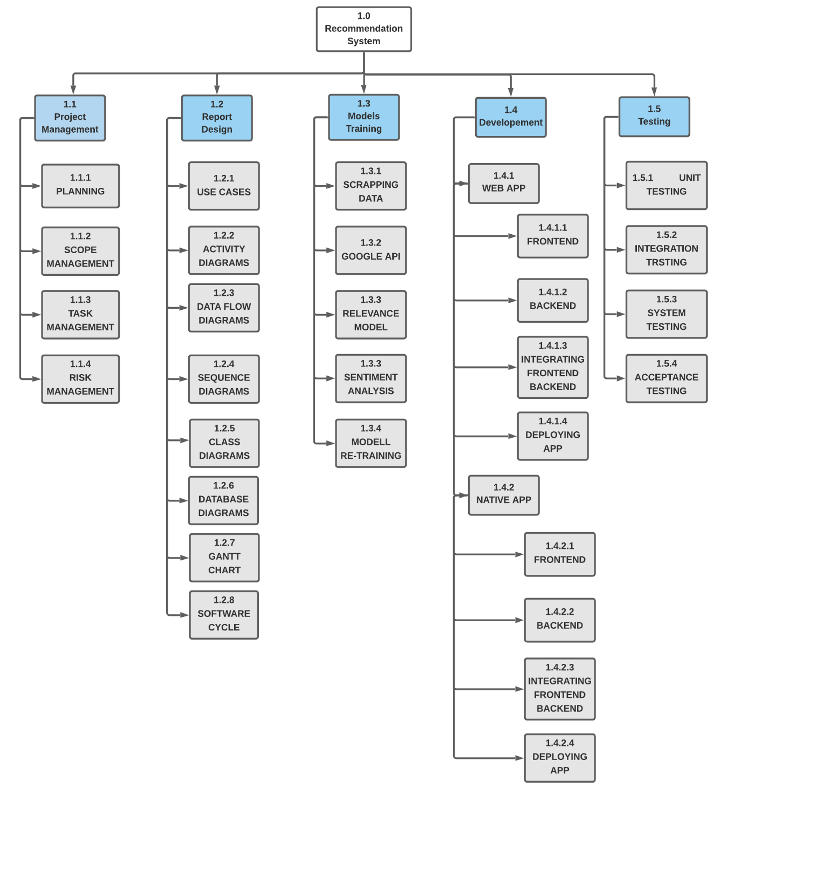

Figure 15: WBS

## Activity diagram

### Login

The flow of activities of login show in Figure 16. The users and admin will enter their credentials, the System will match them with the database and the appropriate function will run.

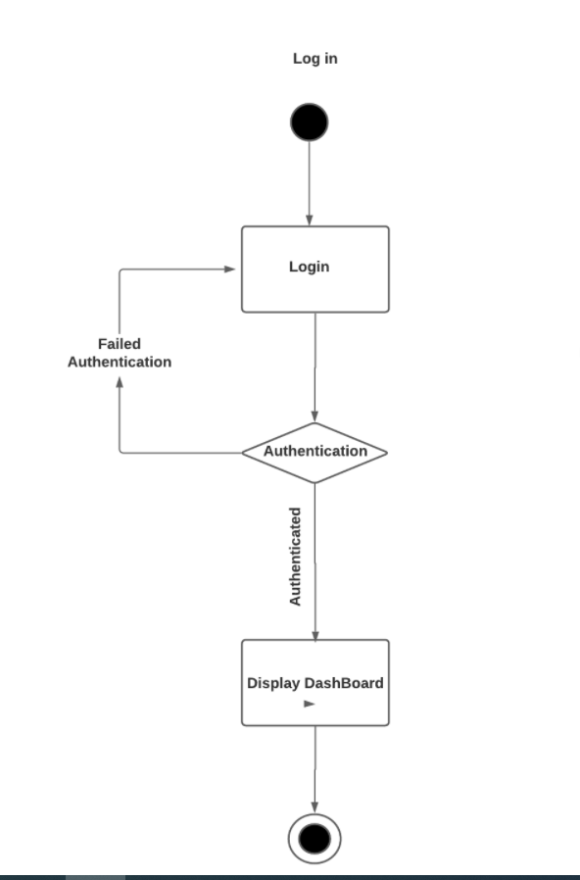

Figure 16: Activity Diagram 1: Login

### Register User

The flow of activities of Register user show in Figure 17.

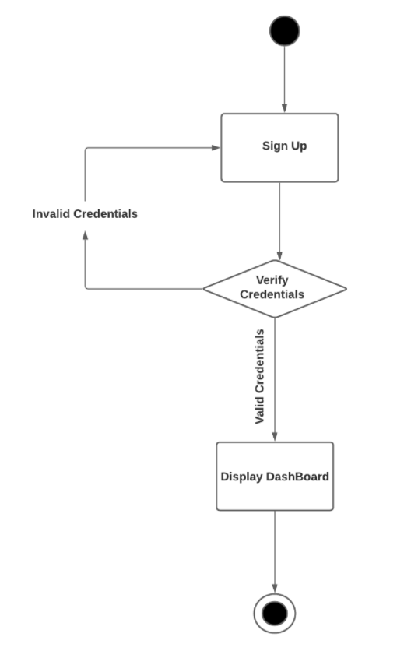

Figure 17: Activity Diagram 2: Register user

### System Recommendations

The activity diagram of the flow of activities of user search result is shown in Figure 18. To give recommendations to the user the system will obtain its location. If the location there in database, places with system ratings will recommended otherwise Google API is used to recommend for the very first time.

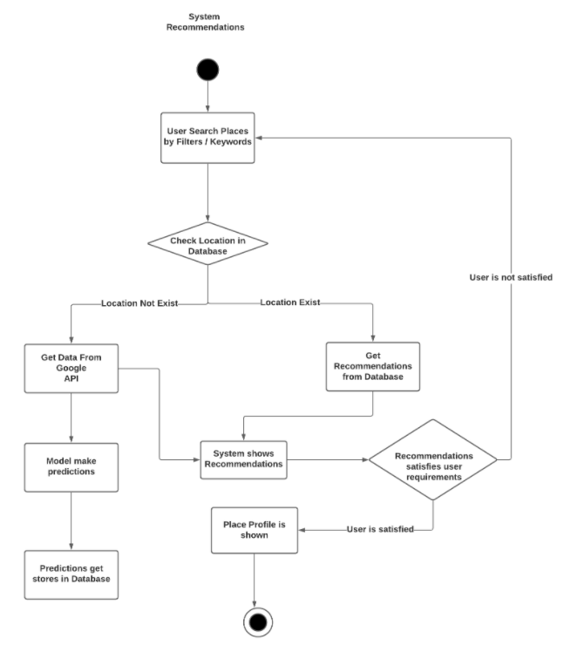

Figure 18: Activity Diagram 3: Recommendation

### Model Re-Training

The activity diagram of the flow of activities of Re-train the model shown in Figure 19. After the defined period of time, feedbacks from the users will be feed to the trained model. Reinforcement learning will come to action; ratings will be updated according to feedbacks. This will make our system ratings dynamic.

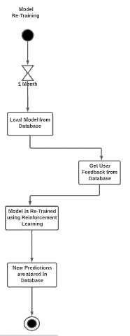

Figure 19: Activity Diagram 4: Model Retraining

## Sequence diagram

### Login Sequence

Figure 20 shows sequence diagram of login, the figure describes each module’s participation in sequence for login.

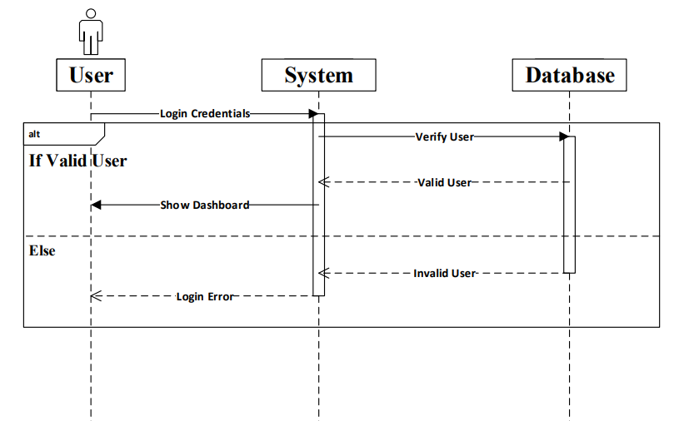

Figure 20: Sequence Diagram: Login

### System Recommendations

Figure 21 shows the whole interaction of user with the application to perform different task. The figure contains the sequence and the activation of each module against the task.

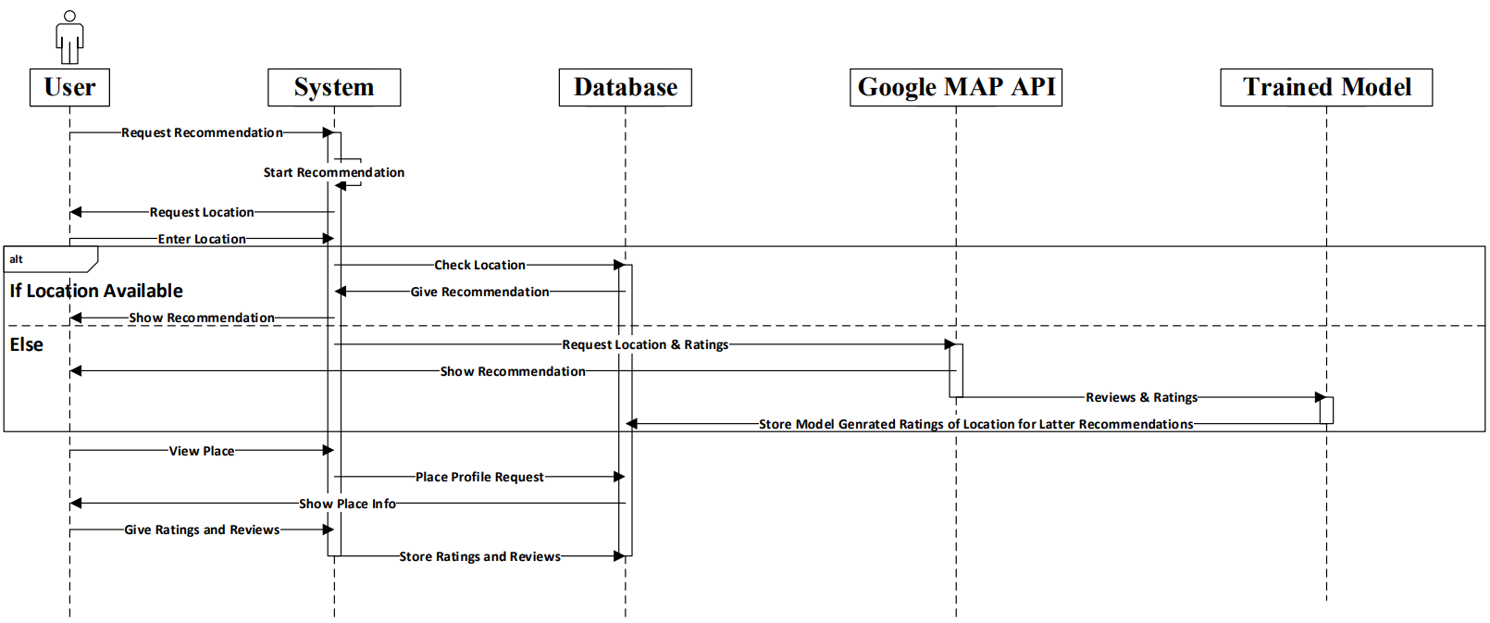

Figure 21: Sequence Diagram: System Recommendations

### Model Re-training

Figure 22 shows the whole process of how the model is retrained and each module’s participation in between

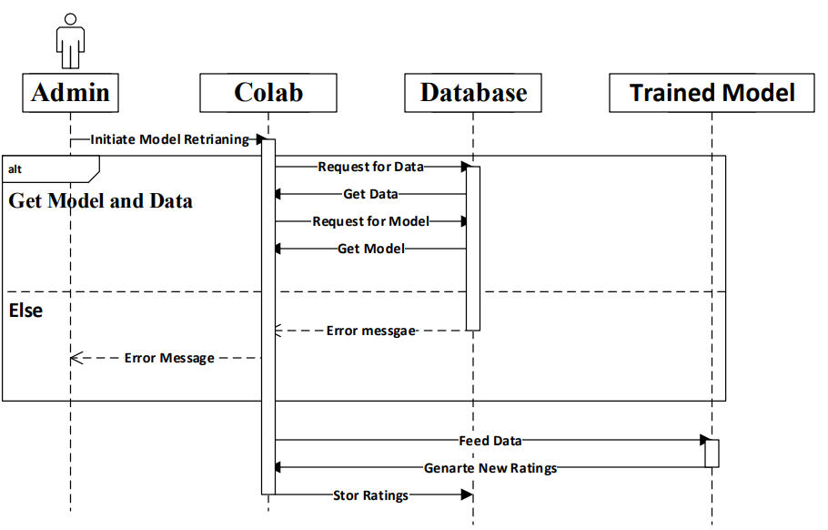

Figure 22: Sequence Diagram: Model Re-Training

## Software architecture

The user will log in to the application, to get the recommendations, he will enter his location, then data will be fetched from the database and shown to the user. The user will give feedback against the recommended places After a defined period, model will be retrained on new feedbacks and system ratings against places will update accordingly. In Figure 23 explained each of the phases.

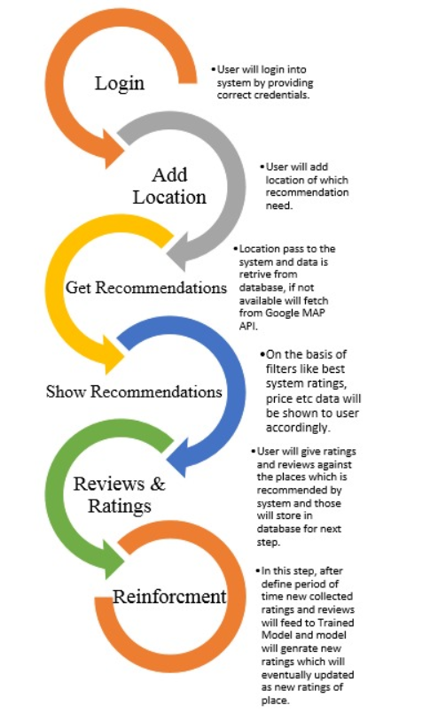

Figure 23: Software Architecture

## Class diagram

Figure 24 shows the class diagram, depicts system’s frontend that how each entity is in relation with the other.

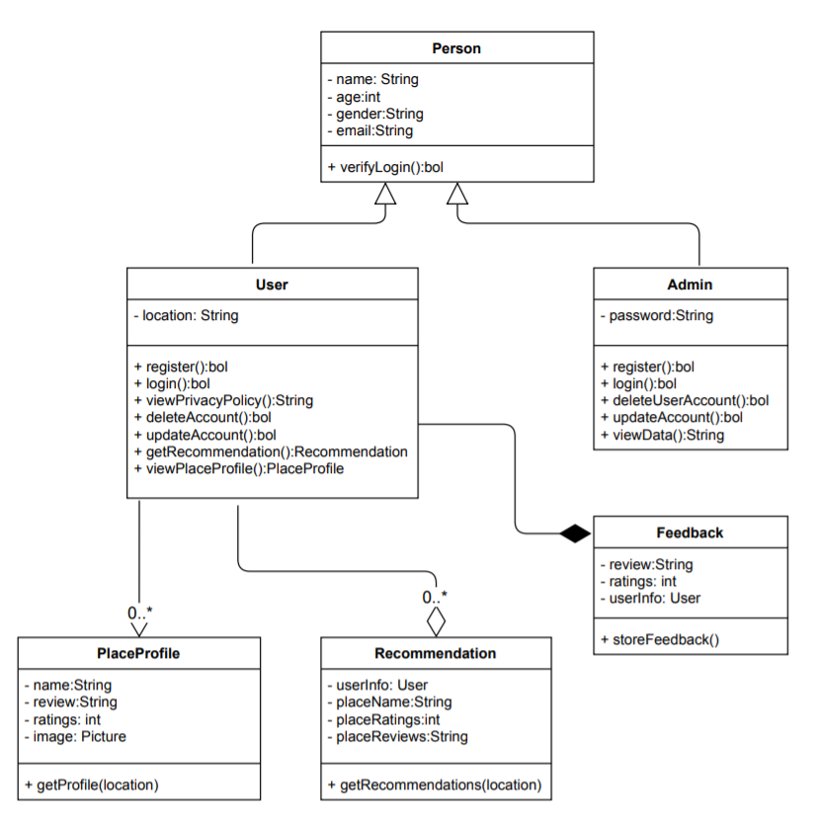

Figure 24: Class Diagram

## Database diagram

Figure 25 shows the database diagram, depicts system’s backend that how each table is in relation with the other.

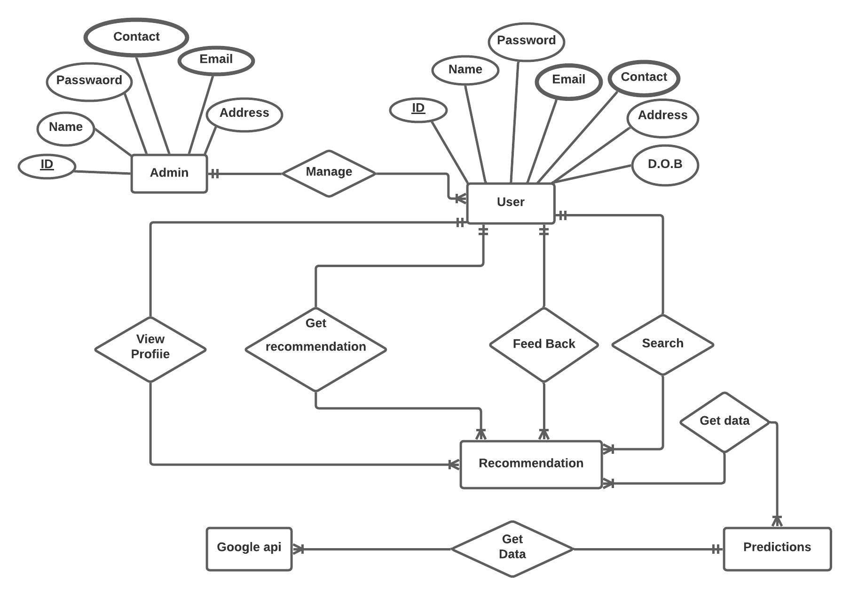

Figure 25: Database Diagram

## 3.7 Network diagram (Gantt chart)

Figure 26 graphically shows each task of the project and the duration in which that will be done. In parallel, tasks are mentioned, and against each of the shaded areas shows the duration.

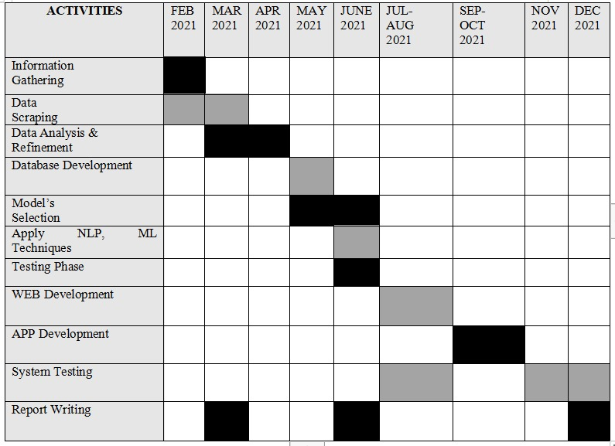

Figure 26: Network Diagram

## 3.8 Collaboration diagram

Figure 27 shows the collaboration diagram for Cleverus. It explains the flow from the user to the backend processes of the application.

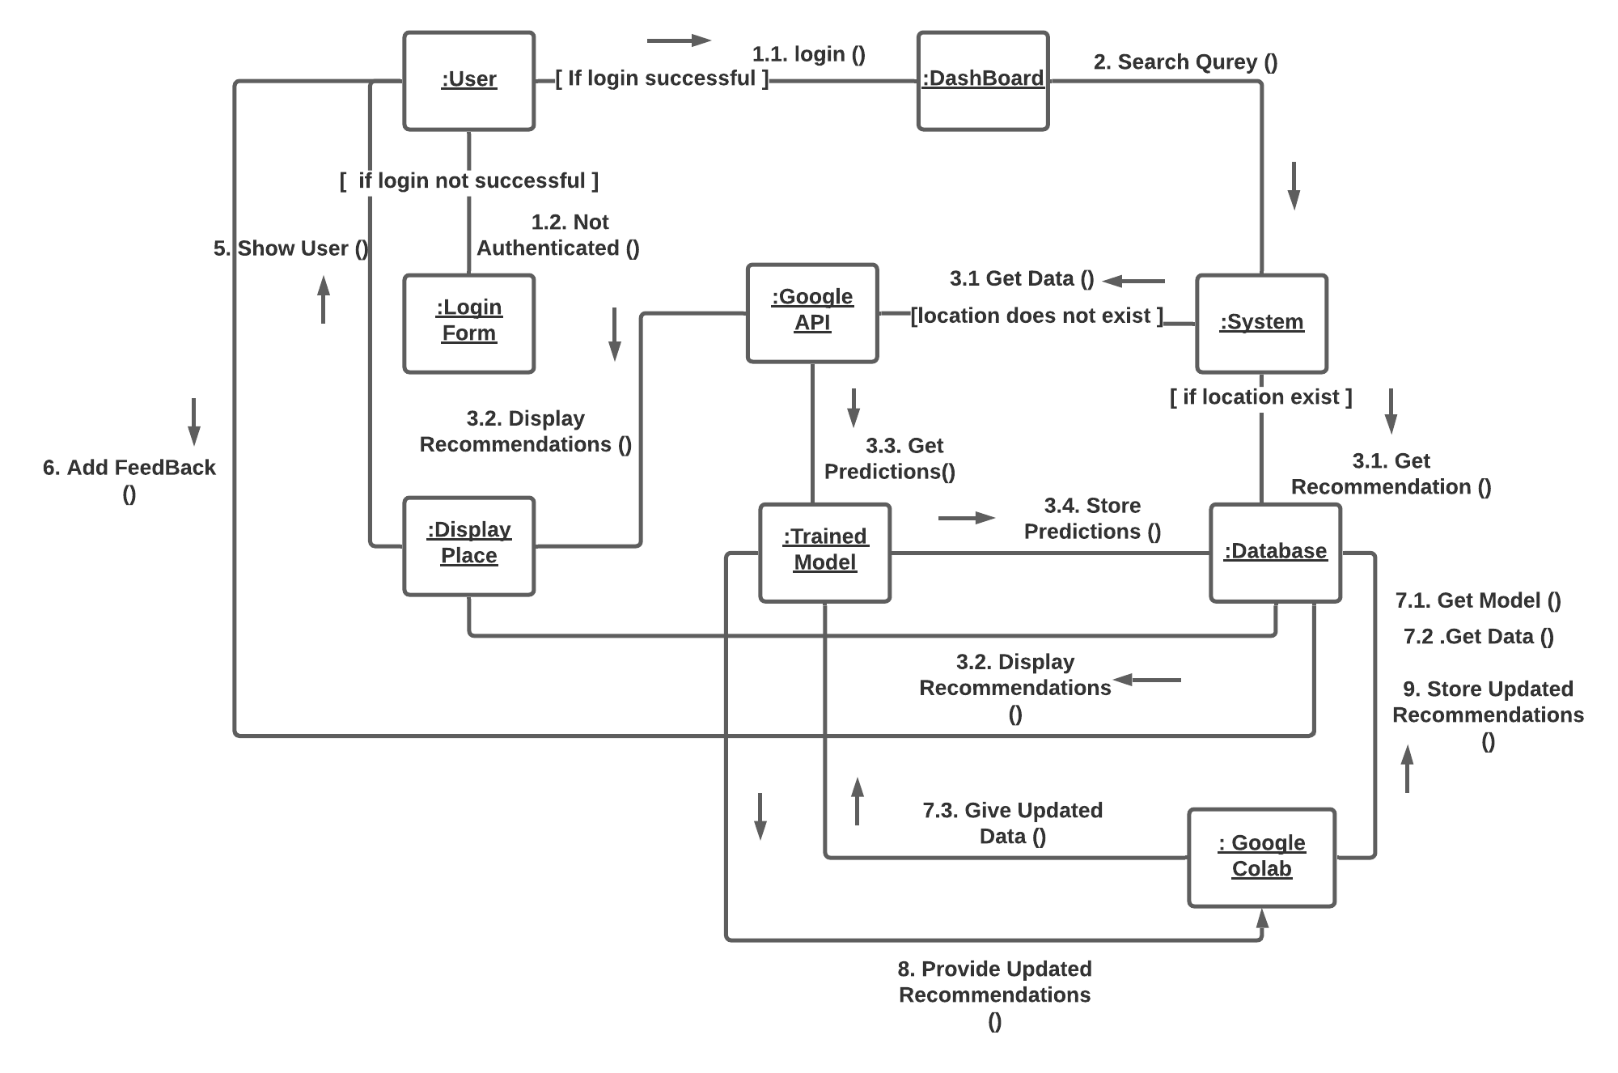

Figure 27: Collaboration Diagram

**Chapter 4**

**System Testing**

# System Testing

## Unit Testing

In unit testing, every one of the segments of the application are exclusively tested. It is the first and most key piece of testing. In this progression, we checked the individual components of our project that execute unit errands and are segments of the task's entire work process.

### Test Case 01: Login

The test case in table 23 shows the test case for the Functional Requirement 02: Login. The table shows that what users can possibly do and what might go wrong if not tested. Aim of the test is to log in with the correct login credentials.

Table 23: Test case-01

|  |  |
| --- | --- |
| Test case Name | TC-01 |
| Application Name | Recommendation System |
| Use Case | Login |
| Input Summary | User will enter its credentials and click the login button. |
| Output Summary | SUCCESS:  User has been logged in successfully.  FAILURE (Expected):  The access has been denied and an error message will be displayed i.e. “Either username or password is incorrect.” |
| Pre-Conditions | User must enter correct login credentials |
| Post-Conditions | User logged in and navigate to its user portal. |

### Test Case 02: Recommendation

The test case in table 24 shows the test case for the Functional Requirement 06: Login. Aim of the test is to show recommendations to user, if the given location is correct.

Table 24: Test case-02

|  |  |
| --- | --- |
| Test case Name | TC-02 |
| Application Name | Recommendation System |
| Use Case | Recommendation |
| Input Summary | User will select the category and enter its location or give access to system’s location. |
| Output Summary | SUCCESS:  Recommendations will be shown to user.  FAILURE (Expected):  There are multiple errors which may occur.   * Invalid location * Server’s access in area etc.   In each case error or problem message related to it will be displayed. |
| Pre-Conditions | User must enter correct location. |
| Post-Conditions | Appropriate recommendations will be shown to user. |

### Test Case 03: Feedback

The test case in table 25 shows the test case for giving feedback against place. Aim of the test is to show save valid feedback of user, if both reviews and ratings are provided.

Table 25: Test case-03

|  |  |
| --- | --- |
| Test case Name | TC-03 |
| Application Name | Recommendation System |
| Use Case | Feedback |
| Input Summary | User will click on the “Give feedback” button and after that user will enter feedback. |
| Output Summary | SUCCESS:  User’s feedback will store in system.  FAILURE (Expected):  There can be 2 types of error   * Either reviews or ratings are missing.   In this case appropriate error message will be shown to user. |
| Pre-Conditions | User must enter all and correct parameters to give feedback. |
| Post-Conditions | User’s feedback will be stored and success message will be displayed. |

### Test Case 04: View Place Profile

The test case in table 26 shows the test case for the Functional Requirement 07: View Place Profile. Aim of the test is to show place pictures, reviews and ratings.

Table 26: Test case-04

|  |  |
| --- | --- |
| Test case Name | TC-04 |
| Application Name | Recommendation System |
| Use Case | View Place Profile |
| Input Summary | User will select the category and search the business in the search bar and then click on the business after getting recommendation. |
| Output Summary | SUCCESS:  Business profile will be shown to user.  FAILURE (Expected):  Error reasons might be “Business not exist”.  In that case appropriate message will be shown to user. |
| Pre-Conditions | User must search for valid place/business name. |
| Post-Conditions | Business profile will be shown to user. |

### Test Case 05: Model Retraining

The test case in table 27 shows the test case for the retraining of model. Aim of the test is to retrain model over new feedbacks and update the ratings of the place.

Table 27: Test case-05

|  |  |
| --- | --- |
| Test case Name | TC-05 |
| Application Name | Recommendation System |
| Use Case | Model Retraining |
| Input Summary | New user feedback and trained model will be accessed on Google Colab by Admin. Then trained model will be feed in the updated user feedbacks. |
| Output Summary | SUCCESS:  Model has been trained successfully on updated recommendations and then these recommendations will be stored in database.  FAILURE (Expected):  There were problems with either user feedbacks or with the train model. |
| Pre-Conditions | Updated feedbacks must be available for retraining. |
| Post-Conditions | Model has been trained successfully on updated user feedbacks and updated recommendations are stored in database. |

## Integration Testing

Integration testing is the second step of the product testing strategy. At this degree of testing, the framework is tried subsequent to joining the different units into bunches. It is to test the deficiencies and blunders in the collaboration between the interacted units. We have not done this testing yet.

## Acceptance Testing

Acceptance testing is characterized as the last advance step for the product testing system. It is to administer whether the necessary details of the framework are met. At this progression, we gauge whether the framework under test is finished with the nuts and bolts and necessities for conclusive handling. We would do this progression toward the finish of the relative multitude of cycles to furnish a framework with appropriate details.

**Chapter 5**

**Conclusion**

# Conclusion

## Problems faced and lessons learned

### Dataset Availability:

Initial problem with starting this project was to find out some reliable, fair quantity and good quality dataset with various end to end business embedded in between. Struggle was big as there is no such dataset available on the internet and for the data crawling part, major websites were not willing to allow.

### Google Colab Limitations:

Provided RAM and storage by the Colab servers are not enough to train NLP problems with sample of the dataset as huge as 500k-600k. Even loading data from JSON file to convert to comma separated format was hard and needs to be divided into batches. Only way to get around was to use partitioning of the data and perform the task into rounds.

### Sentiment Analysis State of the Art Models:

Dataset we had was from Most Famous European Review Community YELP. Dataset was un-annotated which was notifying about another major problem round the corner. Now the race for reliable state of the art sentiment analysis models started which didn’t end that easily. At least 5-7 models were tried on small sampled dataset including Text-Blob, Flair to predict the partiality of reviews. At the end BERT does solve this problem but after training two complete datasets of Twitter and IBDB.

### Team-Work and Task Management

As the time started to pass and project deadline started to plunder, we realize how much of a task our group was assigned and the roadmap we three had to follow to reach some milestone. To follow that roadmap, we had to ensure task management was in order and whole team was putting their full strength in

### Finding Alternatives

It’s must that you will face problems and cons with every step you take towards complex projects. Similar was the case here too as we needed several tweaking’s and alternatives at every inch but that’s how you supposed to become a better debugger and problem solver. Every struggle we had has provided us some knowledge and that how this field has supposed to be, so no worries

## Project summary

We have build a generic and dynamic model which can be able to suggest anything, while the suggestions will be depending on the feedback of the previous users. There is no such application that currently does such a thing in our region. One of the practical, famous, with a high number of users and sophisticatedness, is used in the west, named "Yelp".

The proposed solution is somehow similar to yelp; in which we will generate system ratings of the place on the basis of reviews given by users with the combination of users' ratings. Multiple things would be considered when it comes to the process of generating ratings like polarity of reviews, use of emoji and emoticons, a balance between ratings and reviews. On other hand to make a dynamic system that will not depend on a 1-time rating, rather change over a period of time will depend on the new reviews, we will introduce Reinforcement learning. To train the model we have used the "Yelp" dataset [12] and Kaggle dataset for Hotels [13]. Currently we are working on 4 modules i.e. shopping, restaurants, hotels, and medical and health. One of the plus points of the proposed solution is that we will be able to use the same model for multiple modules, but the constraint will remain, related to the availability of data for that module.

## Future work

Some of the future goals are mentioned below which will help to make recommendation applications more user-friendly, robust and flexible while keeping the quality maintained.

* Integrate more modules over the time according to their need.
* We will create the module using which one will make online bookings; this will save the time of the user as well as will help the service providers to interact with our app in a better way.
* Adding the apoinment section with the domain experts like doctors, property dealers etc.
* Make blog within application where ranked pros publish their experience and reviews to aware the people about the latest insights

**Chapter 6**

**References**

# References

|  |  |
| --- | --- |
| [1] | B. Rocca, “Introduction to recommender systems,” *Towards Data Science,* 3 June 2019. |
| [2] | “UNESCO,” [Online]. Available: http://uis.unesco.org/en/country/pk?theme=education-and-literacy. [Accessed 5 June 2021]. |
| [3] | Dontgiveupworld, “Inspiring Story Of Muniba Mazari,” *Medium.com,* 4 January 2018. |
| [4] | F. Isinkaye, “Recommendation systems: Principles, methods and evaluation,” *Egyptian Informatics Journal,* vol. 16, no. 3, pp. 261-273, November 2015. |
| [5] | S. M. Al-Ghuribi, “Multi-Criteria Review-Based Recommender System – The State of the Ar,” *IEEE,* November 2019. |
| [6] | S. Aciar, “Recommender System Based on Consumer Product Reviews,” December 2006. |
| [7] | “Yelp,” [Online]. Available: https://www.yelp.com/. [Accessed 5 June 2021]. |
| [8] | “Trip Advisor,” [Online]. Available: https://www.tripadvisor.com/. [Accessed 5 June 2021]. |
| [9] | “Urban Spoon,” [Online]. Available: https://play.google.com/store/apps/details?id=com.urbanspoon&hl=en&gl=US. [Accessed 5 June 2021]. |
| [10] | P. Eksombatchai, “An update on Pixie, Pinterest’s recommendation system,” *Medium.com,* 30 November 2018. |
| [11] | D. Chong, “Deep Dive into Netflix’s Recommender System,” *Towards Data Science,* 30 April 2020. |
| [12] | “Dataset, Yepl,” 16 February 2021. [Online]. Available: https://www.kaggle.com/yelp-dataset/yelp-dataset. [Accessed 5 June 2021]. |
| [13] | “Hotel Reviews,” 2015. [Online]. Available: https://www.kaggle.com/datafiniti/hotel-reviews?select=Datafiniti_Hotel_Reviews.csv. [Accessed 5 June 2021]. |

